Final Takedown
1st Annual Girls Folkstyle Wrestling Tournament
Saturday, May 16th, 2026
At Total Turf – Pitman, NJ
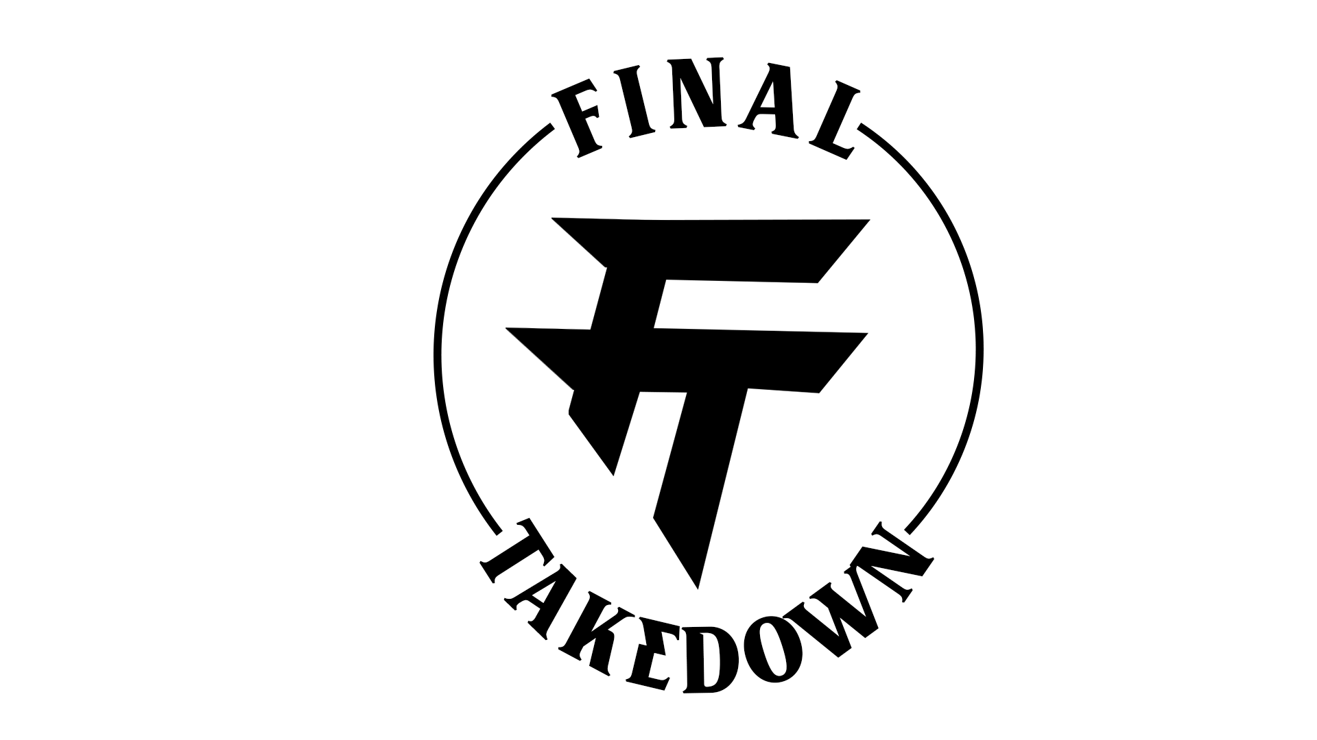
This will be FOLKSTYLE bracketed tournament format
Top 3 awards in all 3 divisions

5th – 8th grade
60, 67, 73, 80, 87, 95, 102, 110, 117, 125, 133, 140, 147, 155, 170, 190, 235

8th grade - HS
102, 109, 116, 123, 128,134, 140, 147, 154, 167, 187, 237
Weight classes may be adjusted accordingly to accommodate entries

Weigh-Ins
- 7:30am – 9am

Wrestling
- Starts – 10am

Entry Cost
- $40 per entry
- Call for Team/Club Team discount
REGISTRATION LINK
(OPEN TILL 10PM THURSDAY, MAY 14TH)


FIND US ON SOCIAL MEDIA
PAYMENT INFO
FIND US ON SOCIAL MEDIA

Contact
Rob Eiter – CEO & Director of events
- rob@finaltakedown.com
- 847-924-3638

