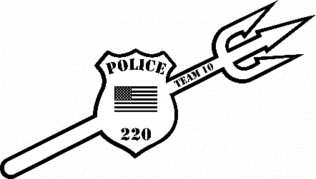
Fallen Heroes Open 2026
Date: Sunday, December 20th, 2026
Location: Beckley Raleigh County Convention Center Beckley, WV

REGISTRATION: Deadline is Friday, December 18th, 2026 by Noon (No walk ins!)
-Online Registration Only at cfeyw.com ***All entries must be received by December 18th at noon.***
Entry fee: $40.00 online registration. Double enter in next age group $20.00. Absolutely No Refunds!!!
Divisions: (NO weight allowance, tournament director has the right to combine weight classes (MUST weigh in a SINGLET) Tournament will be running on 8 mats.
Weight Classes (Birth Year):
4U 2022-present: 35, 40, 45, 50, HWT (Max 65)
6U 2020-2021: 40, 45, 50, 55, 60, 70 HWT (Max 95)
8U 2018-2019: 45, 50, 55, 60, 65, 70, 75, 85,105 HWT (Max 135)
10U 2016-2017: 55, 60, 65, 70, 75, 80, 85, 90, 95, 105, 115,125, HWT (Max 160)
12U 2014-2015: 68,75,82,90,100,110,125,140,160, HWT (200 MAX)
Scholastic Rules: 1-minute periods, overtime sudden death. Referees’ decision is final. Proof of age required if challenged.
Awards: 1st place-Custom Championship Singlet, 2nd-4th places Custom 4.5” Medals
Schedule of Events: This will be a Single Session Tournament (8 mats)
Weigh- ins: Saturday December 19th, 2025, Virtual Weigh Ins through Google Meet or Facetime or In Person Weigh ins 530pm-730pm. All weigh ins must be conducted on Saturday!!!
Coaches Meeting will be held at 11:15 am and wrestling will start at 12:00 pm.
Coaches: 2 coaches per team get free entry. Hospitality Room will be provided all day
For more information, please reach out to Nick Hylton at 304-237-4551 or at coalfieldelite@gmail.com

