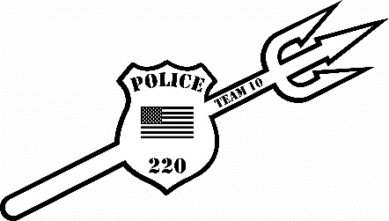
Fallen Heroes Odd Year Novice Tournament 2026

Date: Sunday, December 20, 2026
Location: Beckley Raleigh County Convention Center Beckley, WV
REGISTRATION: Deadline is Friday, December 18th, 2026, by noon (No walk ins!) This is for wrestlers with 3 or less years of experience ONLY!!!!
-Online registration only at cfeyw.com ***All entries must be received by December 18th at noon.***
Entry fee (Novice Only): $22.50 online registration. No double entering. No Refunds!!!
Divisions (Novice Only): (1 lb. weight allowance. Tournament director has right to combine weight classes. (MUST weigh in a SINGLET) Tournament will be running on 8 mats using a bout system.
Novice Division (Birth Years):
5U 2021-Present: 38, 44, 50, 56,64, HWT (Max 85)
7U 2019-2020: 44, 50, 57, 64, 72, 80, 92, 110, HWT (Max 135)
9U 2017-2018: 55, 60, 65, 70, 75, 80, 85, 90, 95, 105, 115,125, HWT (Max 160)
Scholastic Rules: 1-minute periods, overtime sudden death. Referees’ decision is final. Proof of age required if challenged.
Awards: 1st -4th Medals
Schedule of Events: This will be a Single Session Tournament (8 mats)
Weigh- ins: Saturday December 19th, 2025, Virtual Weigh Ins through Google Meet or Facetime or In Person Weigh ins 530pm-730pm. All weigh ins must be conducted on Saturday!!!
Coaches Meeting will be held at 8:15am and wrestling will start at 9:00am.
Coaches: 2 coaches per team get free entry. Extra coaches bands can be purchased for $10. Hospitality Room will be provided all day
For more information please reach out to Nick Hylton at 304-237-4551 or at coalfieldelite@gmail.com

