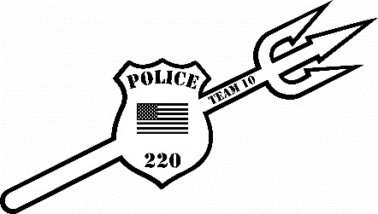
Fallen Heroes Girls Open 2026

Date: Sunday, December 20, 2026
Location: Beckley Raleigh County Convention Center Beckley, WV
REGISTRATION: Deadline is Friday, December 18th, 2026 by noon (No walk ins!)
-Online registration only at cfeyw.com - ***All entries must be received by December 18th at noon.***
******Team entries must be emailed, called or text*******
Entry fee: $40.00 online registration. No double entering, no changing weights. No Refunds!!!
Divisions: (NO weight allowance. Tournament director has the right to combine weight classes. (MUST weigh in a SINGLET) Tournament will be running on 8 mats using a bout system.
G6U 2020-present: 31-39, 40-46, 47-57, 59-69
G9U 2017-2019: 40-48, 49-55, 56-62, 63-69, 70-77, 78-90, 91-103, 104-116
G12U 2014-2016: 57-68, 69-75, 76-84, 85-92, 93-102, 103-116, 117-125, 126-140, 141-160, 161-180
Scholastic Rules: 1-minute periods, overtime sudden death. Referees’ decision is final. Proof of age required if challenged.
Awards: 1st place-Custom Championship Singlet, 2nd-4th places Custom 4.5” Medals
Schedule of Events: This will be a Single Session Tournament (8 mats)
Weigh- ins: Saturday December 19th, 2025, Virtual Weigh Ins through Google Meet or Facetime or In Person Weigh ins 530pm-730pm. All weigh ins must be conducted on Saturday!!!
Coaches Meeting will be held at 8:15am and wrestling will start at 9:00am.
Coaches: 2 coaches per team get free entry. Extra coaches bands can be purchased for $10. Hospitality Room will be provided all day
For more information please reach out to Nick Hylton at 304-237-4551 or at coalfieldelite@gmail.com

