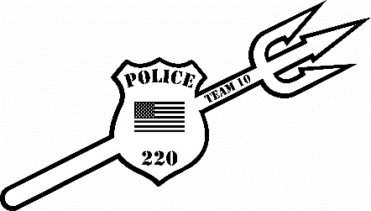
Fallen Heroes Odd Year Novice Tournament 2025

Date: Sunday, December 21, 2025
Location: Beckley Raleigh County Convention Center Beckley, WV
REGISTRATION: Deadline is Wednesday, December 17th, 2025 (No walk ins!) This is for wrestlers with 3 or less years of experience ONLY!!!!
-Register online at cfeyw.com - Call-Ins/Texts – 304-237-4551; E-mail entries- coalfieldelite@gmail.com. ***All entries must be received by December 17th.***
Entry fee (Novice Only): $22.50 online registration. Mail-ins, call-ins, and e-mails $20.00. Make checks out to CFE Youth Wrestling. Double entry $10, must be in different age group, $15 move up fee. No Refunds!!!
Divisions (Novice Only): (1 lb. weight allowance, $15 move up fee. Tournament director has right to combine weight classes. (MUST weigh in a SINGLET) Tournament will be running on 8 mats using a bout system.
Novice Division (Birth Years):
5U 2020-Present: 38, 44, 50, 56,64, HWT (Max 85)
7U 2018-2019: 44, 50, 57, 64, 72, 80, 92, 110, HWT (Max 135)
9U 2016-2017: 55, 60, 65, 70, 75, 80, 85, 90, 95, 105, 115,125, HWT (Max 160)
Scholastic Rules: 1-minute periods, overtime sudden death. Referees’ decision is final. Proof of age required if challenged.
Awards: 1st -4th Medals
Schedule of Events: This will be a Single Session Tournament (8 mats)
Weigh- ins: Saturday December 20st, 2025, 5:30pm-7:00 pm
Sunday December 21st, 2025, 6:30 am-8:00am
Coaches Meeting will be held at 8:30am and wrestling will start at 9:00am.
Coaches: 2 coaches per team get free entry. Extra coaches bands can be purchased for $10. Hospitality Room will be provided all day
For more information please reach out to Nick Hylton at 304-237-4551 or at coalfieldelite@gmail.com
REGISTRATION FORM
Please attach to email or mail-in
Name: _________________________________________________
Address: _______________________________________________
Phone #: ________________________________________________
Team: __________________________________________________
Age Group: __________________
Weight Class:______________
Upon acceptance of my entry, I agree that I am legally bound and wave all members of Coalfield Elite Youth Wrestling and the affiliates, sponsors, organizations from any claims to injures, damages, and property losses while attending and/or participating in the tournament.
Parent/Guardian Signature: ___________________________________
Make checks payable to: CFE Youth Wrestling

