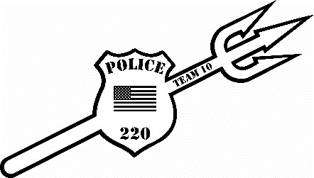
Fallen Heroes Girls Open 2025

Date: Sunday, December 21, 2025
Location: Beckley Raleigh County Convention Center Beckley, WV
REGISTRATION: Deadline is Wednesday, December 17th, 2025 (No walk ins!)
-Register online at cfeyw.com - Call-Ins/Texts – 304-237-4551; E-mail entries- coalfieldelite@gmail.com. ***All entries must be received by December 17th.***
******Team entries must be emailed, called or text*******
Entry fee: $37.50 online registration. Mail-ins, call-ins, and e-mails $35.00. Team entries of 10 or more $30. Must email team entries!!! Make checks out to CFE Youth Wrestling. No double entering, no changing of weights. No Refunds!!!
Divisions: (NO weight allowance, $15 move up fee, Tournament director has the right to combine weight classes. (MUST weigh in a SINGLET) Tournament will be running on 8 mats using a bout system.
G6U 2019-present: 31-39, 40-46, 47-57, 59-69
G9U 2016-2018: 40-48, 49-55, 56-62, 63-69, 70-77, 78-90, 91-103, 104-116
G12U 2013-2015: 57-68, 69-75, 76-84, 85-92, 93-102, 103-116, 117-125, 126-140, 141-160, 161-180
Scholastic Rules: 1-minute periods, overtime sudden death. Referees’ decision is final. Proof of age required if challenged.
Awards: 1st place-Custom Championship Singlet, 2nd-4th places Custom 4.5” Medals
Schedule of Events: This will be a Single Session Tournament (8 mats)
Weigh- ins: Saturday December 20st, 2025, 5:30pm-7:00 pm
Sunday December 21st, 2025, 6:30 am-8:00am
Coaches Meeting will be held at 8:30am and wrestling will start at 9:00am.
Coaches: 2 coaches per team get free entry. Extra coaches bands can be purchased for $10. Hospitality Room will be provided all day
For more information please reach out to Nick Hylton at 304-237-4551 or at coalfieldelite@gmail.com

REGISTRATION FORM
Please attach to email or mail-in
Name: _________________________________________________
Address: _______________________________________________
Phone #: ________________________________________________
Team: __________________________________________________
Age Group: __________________
Weight Class:______________
Upon acceptance of my entry, I agree that I am legally bound and wave all members of Coalfield Elite Youth Wrestling and the affiliates, sponsors, organizations from any claims to injures, damages, and property losses while attending and/or participating in the tournament.
Parent/Guardian Signature: ___________________________________
Make checks payable to: CFE Youth Wrestling

