**2026 TEXAN TUMBLEWEED CLASSIC**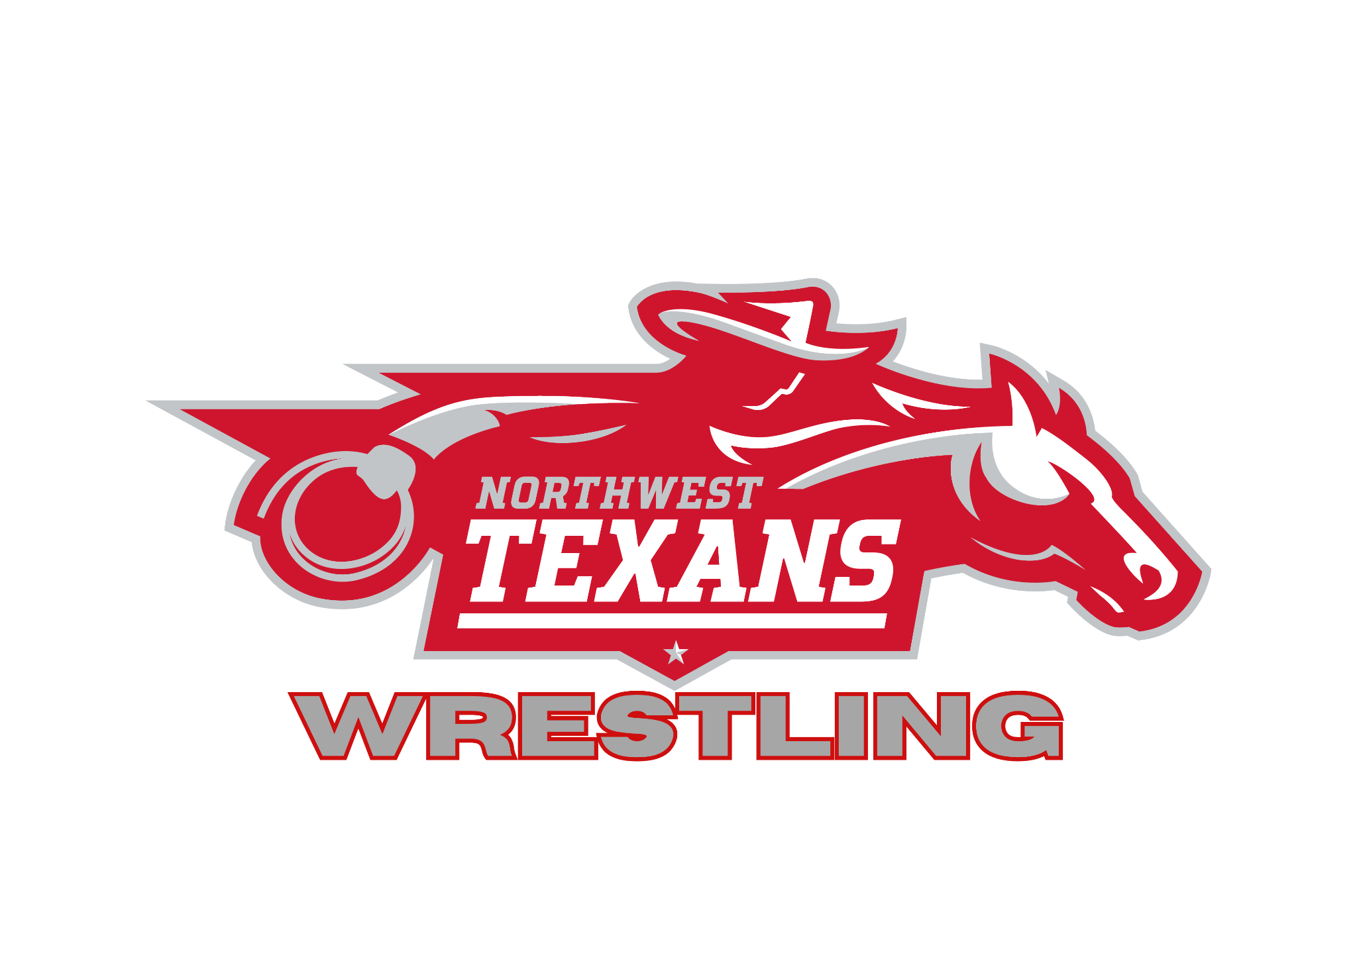

**January 16 - 17 , 2026**

**NORTHWEST HIGH SCHOOL**

**2301 TEXAN DRIVE**

**JUSTIN, TX 76247**

**COST**

**MENS VARSITY - $250 PER TEAM**

**WOMEN’S VARSITY - $250 PER TEAM**

**JUNIOR VARSITY (MEN AND WOMEN’S DIVISIONS) - $20 PER KID**

**CHECKS MADE PAYABLE TO**

**NORTHWEST HIGH SCHOOL**

**ATTN: WARREN SMITH – HEAD WRESTLING COACH**

**2701 TEXAN DR., JUSTIN, TEXAS 76247**

**WEIGH – IN INFORMATION**

**Friday January 16, 2026**

* **Junior Varsity Boys and Girls**
  + **9:00 AM**

**Saturday January 17, 2026**

* **Varsity Boys and Girls**
  + **8:00 AM**

**WRESTLING INFORMATION**

**Friday January 16, 2026**

* **Junior Varsity Boys and Girls**
  + **10:00 AM**

**Saturday January 17, 2026**

* **Varsity Boys and Girls**
  + **9:00 AM**

|  |  |  |
| --- | --- | --- |
| **VARSITY FORMAT** | **JUNIOR VARSITY FORMAT** | **THERE WILL BE NO SEEDING MEETING FOR THIS TOURNAMENT. ALL INFORMATION MUST BE IN TRACK NO LATER THAN JAN. 15, 2026 @ 6:00 PM. LOGIN INFORMATION AND DEADLINES WILL BE EMAILED TO YOU THE WEEK BEFORE THE TOURNAMENT.** |
| **16 MAN BRACKETS**  **2 – 2 – 2 CHAMPIONSHIP**  **1 – 2 – 2 CONSOLATION** | **8 MAN BRACKETS**  **2 – 1 – 1 CHAMPIONSHIP**  **2 – 1 – 1 CONSOLATION** |

|  |  |  |
| --- | --- | --- |
| **VARSITY AWARDS** | **JUNIOR VARSITY AWARDS** | **CONTACT INFORMATION** |
| **TEAM TROPHY: 1ST – 3RD**  **INDIVIDUAL: 1ST – 4TH**  **BOYS/GIRLS INDIVIDUAL MOW** | **INDIVIDUAL AWARDS 1ST – 4TH PLACE** | **WARREN SMITH**  **HEAD WRESTLING COACH**  **WARREN.SMITH@NISDTX.ORG** |

**ANYONE, WRESTLER, COACH OR FAN NOT ABIDING BY THE RULES IS SUBJECT TO BEING REMOVED FROM THE TOURNAMENT AND ARENA.**