33rd Annual TRI-CAP Wrestling Club Tournament
Saturday, December 3rd, 2022
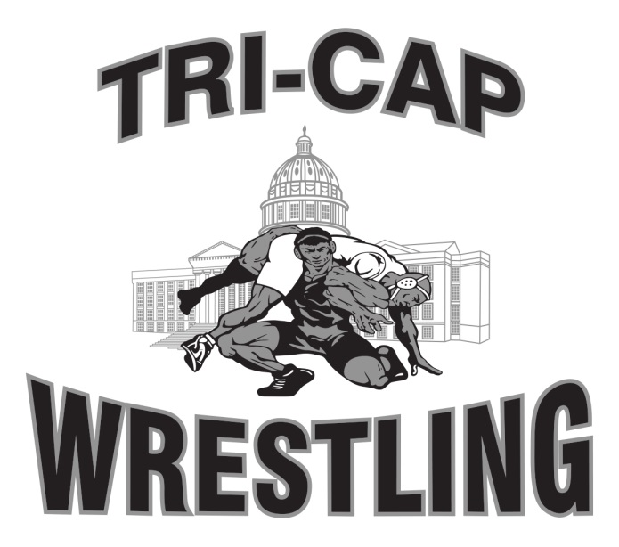
Weigh-Ins Times:
Friday, December 2nd, 6:30 – 7:30 p.m. (Singlet)
Saturday, December 3rd, 6:30 – 8:00 a.m. (Singlet)
Coaches Meeting: 8:40 a.m. SHARP
Wrestling Begins: 9:00 a.m.
Entry Fee: $30 Non-Refundable
$10 extra for weight changes after November 28th
Registration: by e-mail
General Admission: FREE

Location: Helias Catholic High School,
1305 Swifts Highway, Jefferson City, MO 65109

Registration: Please e-mail Excel spreadsheet of your rosters with exact weights, USAW card numbers and ratings to:
tricapwrestlingclub@hotmail.com

Mail a copy of the roster along with payment (make checks payable to: TRI-CAP Wrestling Club) to:

Aaron Hemmel
2229 Moreau Terrace Jefferson City, MO 65101
Questions please call: 573-694-2115

WRESTLER’S AGE AS OF December 31, 2022 WILL DETERMINE AGE GROUP - ABSOLUTELY NO HIGH SCHOOL STUDENTS
Entries must be received by Monday, November 28th 2022

NOTE: Entry limited to first 500 wrestlers. Payment must be with registration. Wrestler & Coach’s cards are required.
Tournament Format: round robin brackets with closest weights and rating. There will be as many 5 person brackets where feasible. Only two coaches permitted mat side. Medals will be awarded for 1st – 3rd place. Weights may be combined where a small number of entries exist.
Match Periods: 6U & 8U (1-1-1); 10U, 12U & 14U (1 ½ - 1 ½ - 1 ½), Overtime Periods (Sudden Victory – 30 seconds per MSHAA Rules), 1 hour rest period not in effect.

PLEASE USE THE FOLLOWING RATING TO SEED YOUR WRESTLERS:
Please use 2020-21 results for ratings. (1) State Place Finisher – 1-8 place (list place) (2) Good Wrestler – State Qualifier (3) Experienced wrestler but has not qualified for state (4) 1st or 2nd year wrestler (novices only)

Refreshments: Breakfast, lunch and snacks will be served from the concession stand. We have a hospitality room for coaches and officials.

TRI-CAP WRESTLING CLUB (coaches and members), HELIAS CATHOLIC HIGH SCHOOL, HELIAS CATHOLIC STAFF, AND ALL TOURNAMENT WORKERS WILL NOT BE RESPONSIBLE FOR ACCIDENTS OR THEFT OF ITEMS AT THIS EVENT.

