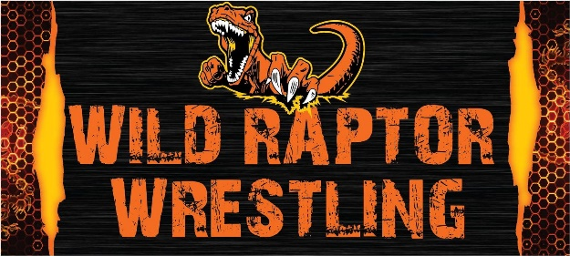
Wild Raptor Wrestling Club
2021-2022 Youth Tournament
** Team Trophies **
Sunday, December 19, 2021
Schaller-Crestland Elementary Gym, Schaller, IA

Divisions: | Weigh-In: | Start Time:
Super Pee Wee (TK-K), Pee Wee (1st-2nd) | 9:30a-10:30am | Approximate 11:15am
Novice (3rd-4th), Jr. (5th-6th), Sr. (7th-8th) | 9:30a-11:30am | After Super Pee Wee & Pee Wee
Bracketing and Awards: Round robins with 4-man brackets (when possible). Wrestlers from same town/club will be placed in different brackets when possible. All wrestlers will be awarded medals. Champion receives medal and bracket.
Team Trophies: 1st and 2nd place team trophies will be awarded. 10 wrestlers/team max. Team rosters to be turned in on-site prior to posting of TK-2nd grade brackets. Team entry fee $10.00 to be paid on-site.
Admission (non-wrestlers): Adults $5.00, Students $3.00. Concessions available on site.
Bad weather? Listen to KAYL 101.7 FM Visit http://stormlakeradio.com
Questions? Contact Josh Kephart @ 712-660-1292 or joshkep1292@hotmail.com

------------------------------------------------------------------ ENTRY FORM -------------------------------------------------------------------------
$15- Advanced/Mail Entry- postmarked by December 13th, 2021
Mail entry to Keith Thompson, PO Box 412, Schaller, IA 51053
$20 at the door – walk in’s welcome
Make checks payable to “Wild Raptor Wrestling Club” NO REFUNDS

Name: ___________________________________ Age: _________ Grade: _____________
Team: ________________________________________________________________
Division: ________________________________________
Skill Level: Beginner Average/Intermediate Advanced
Address: _______________________________________________________________
City: __________________ State: _________________ Zip: ______________________
I certify that ________________________________________________ is the age and grade stated above and has my full permission to compete in the Wild Raptor Wrestling Club Youth Tournament. I accept full responsibility for our wrestler’s behavior and participation in the tournament. I release the Wild Raptor Wrestling Club, Schaller-Crestland CSD, and all other individuals assisting with the tournament from all liability for any accidents or injuries sustained by my wrestler, me, or any companions during the tournament (including arrival and departure). The Wild Raptor Wrestling Club is not responsible for lost or stolen items.
Printed name of Parent/Guardian: ________________________________________________
Signature of Parent/Guardian: ____________________________________________________
Parent/Guardian Phone/Email: ____________________________________________________

