

2021 Boot-Heel Brawl Dual Tournament

USA Wrestling sanctioned

DATE: Sunday December 05, 2021

LOCATION: Cape Jr. High School - 1920 Whitener Street Cape Girardeau, MO 63701

ADMISSION: $5 per person- 10 Under are free.

TIME: Wrestling starts at 9:00 A.M. Gym opens at 7:45 A.M.

**DIVISIONS:**  **K-5TH GRADE 5-8th GRADE VALID USA CARDS REQUIRED**

Each Team will create a team **predominately from their club**. Teams will be allowed to have five wrestlers that are not from their club, only add others to fill openings not to stack your team. There will be no restrictions on these members so long as they are within the appropriate age and weight. Age groups based on grade in 2021/22. Clubs must provide 1 table workers per dual

**FORMAT:** Round robin format, teams will cross bracket to Gold and Silver divisions, each team gets 5 duals

Team placement will be based on win to loss ratio then overall points scored.

MSHSS/USA RULES with 1:30 PERIODS Full sized mats

SCORING: Team Points 3 (decision), 4 (major decision), 5 (tech fall), 6 (pin), (4) Forfeit

**ENTRY FEE**: $400 per team, $700 if you bring 2 teams make checks payable to Jackson USA Wrestling.

**8 Team Limit per division**

**WEIGHT INS**: NO WEIGHT ALLOWANCE/MUST WEAR SINGLET

Saturday weigh in’s 6-7:30 PM @ the school

Sunday weigh in’s at 8:00 am NO WEIGHT ALLOWANCE/MUST WEAR SINGLET/SKIN CHECK

Coaches will be required to submit their roster to [officers@jacksonusawrestling.org](mailto:officers@jacksonusawrestling.org) identifying the wrestler in each weight class. Roster is attached to the flyer. Deadline for Team Entries is November 26, 2021

POINT OF CONTACT: Lance Schlick @ [lschlick1@icloud.com](mailto:lschlick1@icloud.com)

AWARDS: Tomahawk plaque for to the champion team and trophies for second and third place team. A quick pin award will be presented to the wrestler with the fastest pin

***Discounted block of rooms available through Drury Inn in Cape Girardeau

Please contact me if you are interested

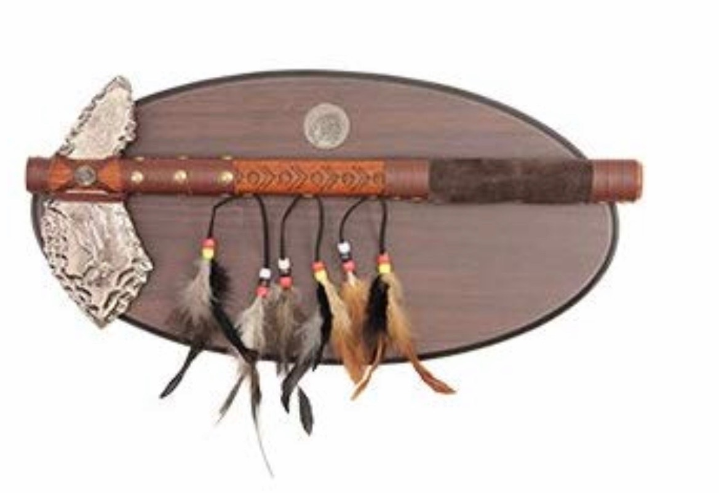

**BOOT-HEEL BRAWL** **Dual Roster**

Team Name:______________________

Age Division:  **K-5TH GRADE**

Head Coach:______________________

Weight: Wrestlers Name: USA Card # D.O.B./grade

46:___________________________________________________________________________

50:___________________________________________________________________________

54:___________________________________________________________________________

58:___________________________________________________________________________

62:___________________________________________________________________________

66:___________________________________________________________________________

70:___________________________________________________________________________

75:___________________________________________________________________________

80:___________________________________________________________________________

85:___________________________________________________________________________

90:___________________________________________________________________________

96:___________________________________________________________________________

103:___________________________________________________________________________

116:___________________________________________________________________________

HWT:___________________________________________________________________________



**BOOT-HEEL BRAWL** **Dual Roster**

Team Name:______________________

Age Division:  **5-8TH GRADE**

Head Coach:______________________

Weight: Wrestlers Name: USA Card # D.O.B./grade

65:___________________________________________________________________________

70:___________________________________________________________________________

75:___________________________________________________________________________

80:___________________________________________________________________________

85:___________________________________________________________________________

90:___________________________________________________________________________

95:___________________________________________________________________________

100:___________________________________________________________________________

107:___________________________________________________________________________

114:___________________________________________________________________________

122:___________________________________________________________________________

132:___________________________________________________________________________

145:___________________________________________________________________________

160:___________________________________________________________________________

HWT:___________________________________________________________________________

